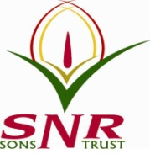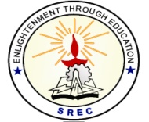**SRI RAMAKRISHNA ENGINEERING COLLEGE**

[Educational Service: SNR Sons Charitable Trust]

[Autonomous Institution, Reaccredited by NAAC with ‘A+’ Grade]

[Approved by AICTE and Permanently Affiliated to Anna University, Chennai]

[ISO 9001:2015 Certified and all eligible programmes Accredited by NBA]

**VATTAMALAIPALAYAM, N.G.G.O. COLONY POST, COIMBATORE – 641 022**

**SREC – IP CELL**

**Date: 11.02.2023**

**Report for Guest Lecture on IP Filing and Commercialization:**

A Guest Lecture on IP Filing and Commercialization has been conducted on 10th February 2023 for the faculty members of Sri Ramakrishna Engineering College in association with MHRD-IIC and CSI-Student’s Branch at CSE Seminar Hall. Ms. Elizabeth Puthran, Patent & Trade Mark Attorney, Puthran & Associates - Founder Partner, Chennai gave a talk on “IP Filing and Commercialization”. The opening remarks was given by Dr.M.S.Geetha Devasena, Professor/CSE.

Dr. S. Deivanayaki, Assistant Professor (Sl.Grade)/Physics welcomed the gathering, The introduction to the resource person was given by Dr. Kalaiarasu, Associate Professor/IT. Dr. R. Kingsy Grace, Associate Professor/CSE delivered the vote of thanks. This guest talk benefited 50 faculty members.

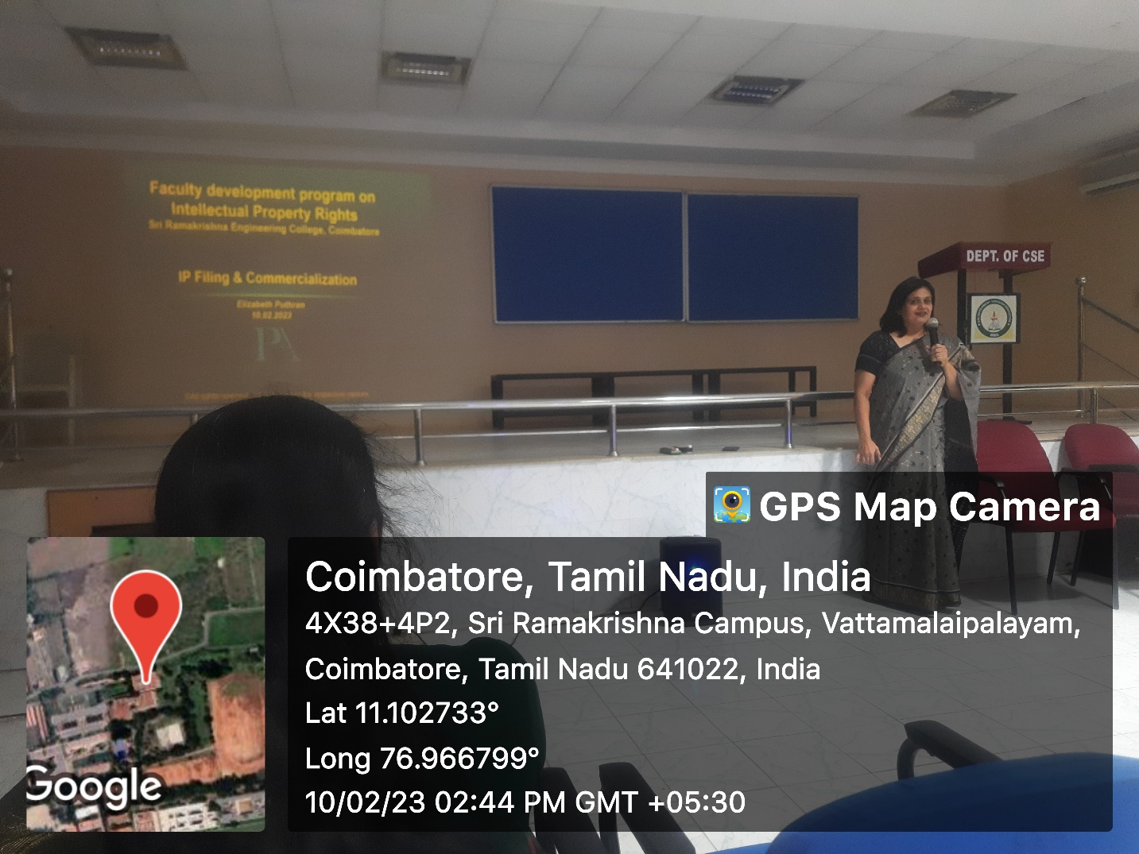

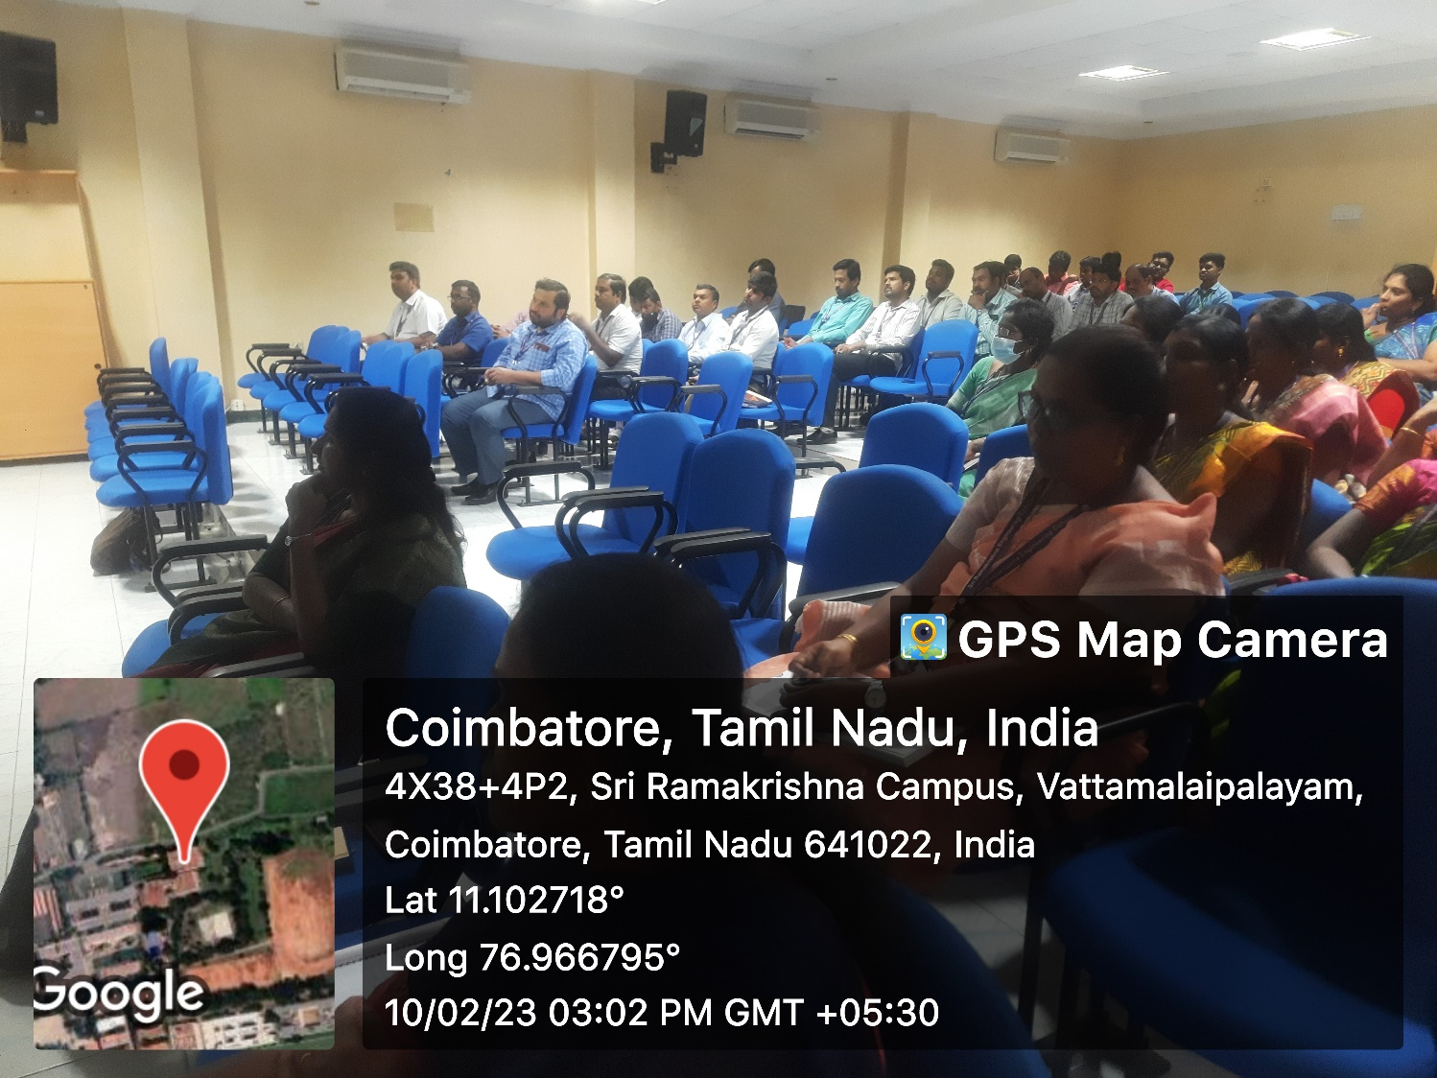

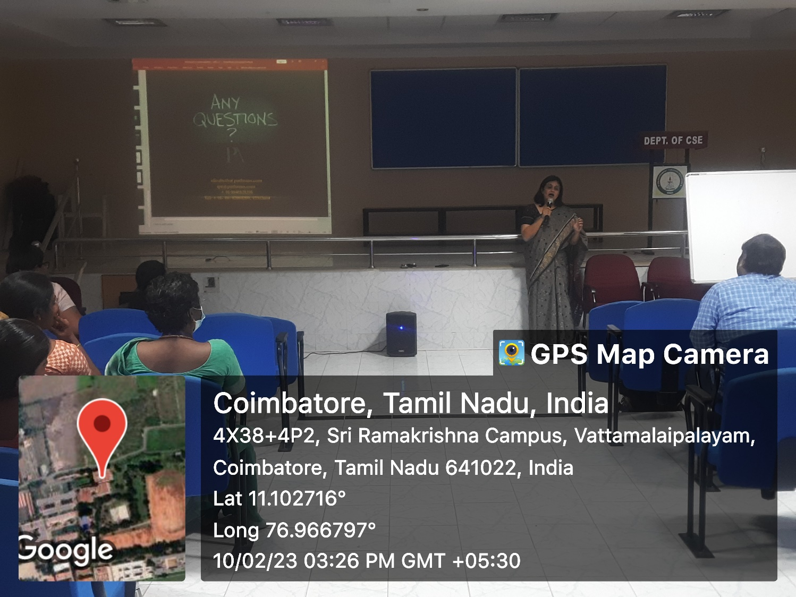

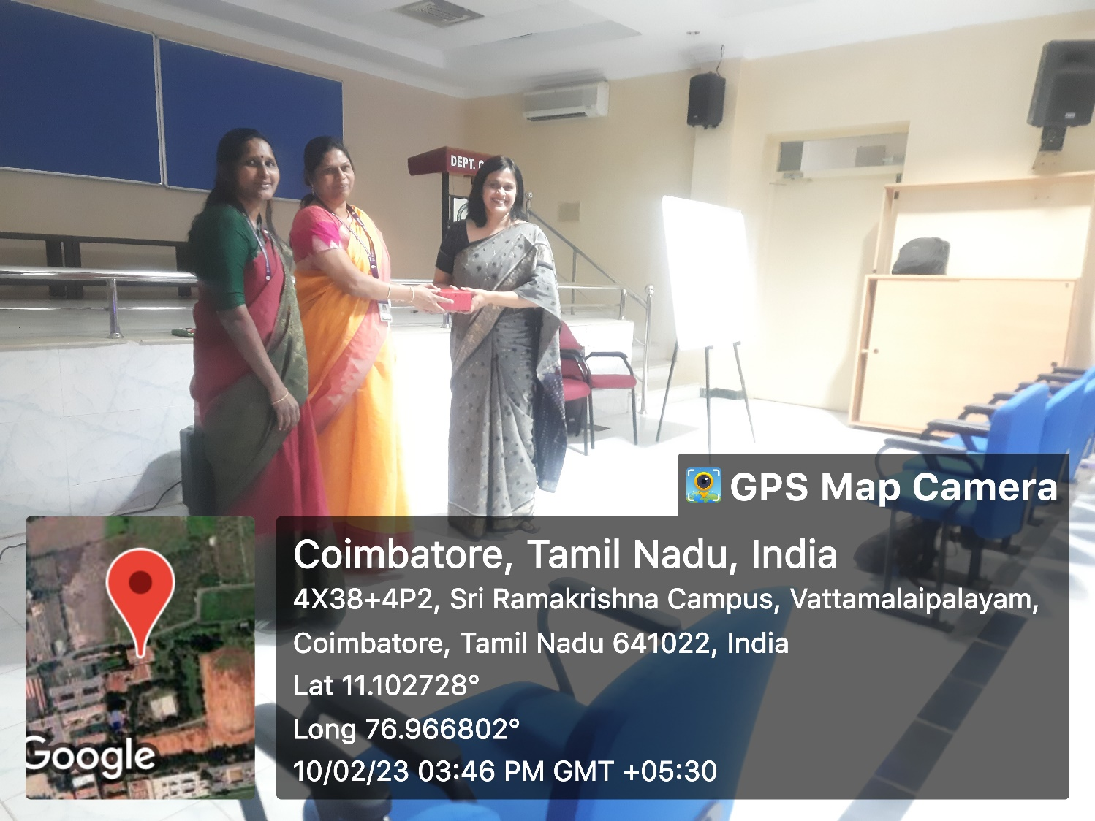

**HEAD – IP CELL**

**Dr. M. S. Geetha Devasena, P/CSE**